

Accessibility Policy

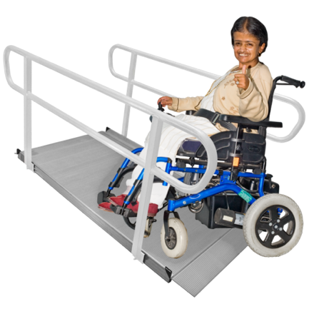 | Komedia Bath is committed to be accessible to all. Customers who require the assistance of a Personal Assistant are entitled to one free ticket with their purchased ticket. These are available via phone 01225 489070 (Monday - Saturday 10am-5pm) in person at our Box Office (Tuesday - Saturday 10am-5pm) or you can email us on access@komediabath.co.uk (we will reply within 5 working days)
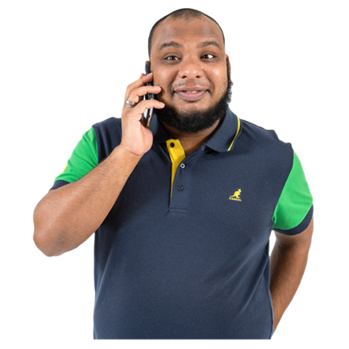 | If you are unable to queue and/or require early access, please let us know when booking (either let us know in person/via the phone or write it into the COMMENTS box before checkout when booking your tickets online) and we will arrange access for you.
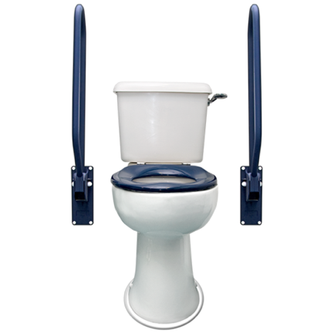 | There are fully accessible toilets at the back of the Auditorium, 3 to 10 metres away from the viewing area on the mezzanine.

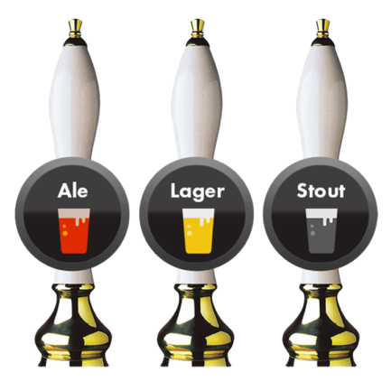 | The foyer bar has low level access for wheelchair users. The Auditorium bar has plenty of space to access at a low level on the left-hand side.
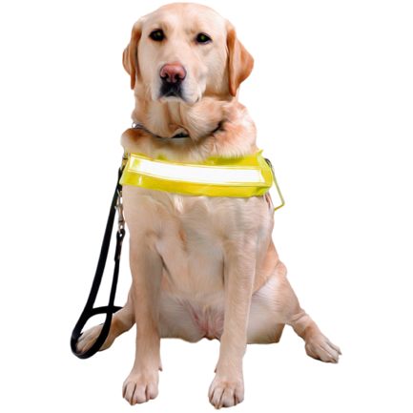 | We welcome guide & assistant dogs at all our events. Please let us know about your attendance with an assistance dog in advance.
Booking your event

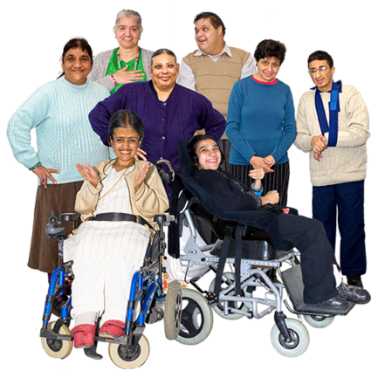 | We advise wheelchair users to book in advance to guarantee access and in order that we can reserve a suitable table or seating for the whole party.
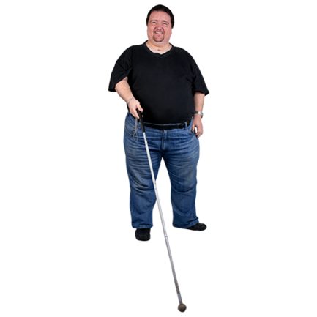 | Visually impaired customers are advised to inform us when booking tickets in order that we can arrange for suitable seating.

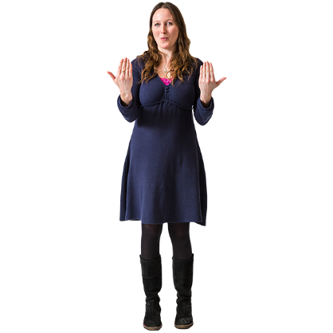 | When booking for a show with a BSL interpreter and you require to be seated in sight of the interpreter, please let us now when booking (either let us know in person/ via the phone or write it into the COMMENTS box before checkout when booking your tickets online) and we will arrange this for you.
 | Large print menus and wine lists are available on request.
Access to the specific areas at Komedia
Click here for an interactive 3D Map of Komedia Bath

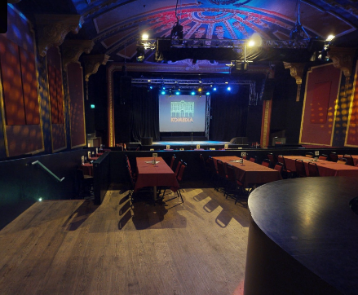 | The Auditorium has fully level access. The accessible toilets are on the left as you come in. Seating options depend on how we set up the show, if you are unsure which area to book, please get in contact with us. There is a ramp going down to the front of the stage, too.
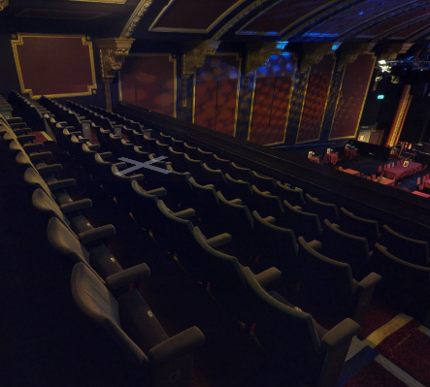 | The Balcony is only accessible via a staircase. The staircase has 5 sets of 8, 5, 8, 3 and 4 steps. Balcony seating is tiered, and laid out in fixed rows of theatre-style, fold-down seats. The Balcony floor is not sloped but has wide, low steps.

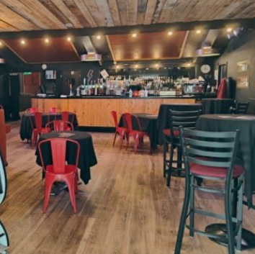 | The Electric Bar is our smaller performance space and uses the same entrance and as Auditorium shows. This area is step-free.
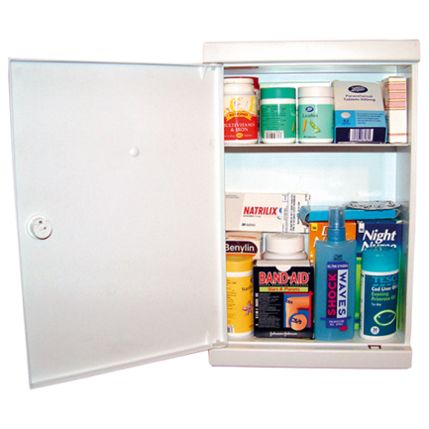 | Medical Requirements  If any medication or essential food and drink are required at our events, we are happy to help.  Just let us know so we can tell our staff team working on the night.
 | Strobe Lighting Policy  Strobe Lighting may be used for events and club nights. If required, we can let you know in advance if a specific event is using Strobe Lighting or not.  If heavy strobe lighting is being used warning signs will be placed around the venue.
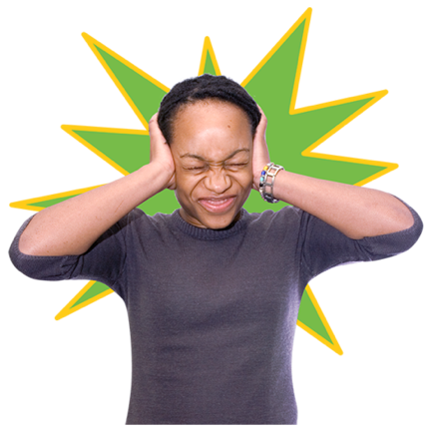 | Sound Levels  Some gigs are meant to be loud but they should also be safe.  For this reason we keep a close eye on decibel levels and we also have ear plugs at the bar and box office for every event.

